The Cake Website

E-Project

Design Guide

Group Members

|  |  |
| --- | --- |
| Enrollment ID | Name |
| Student14117943 | Abdul Rehman Noor |
| Student |  |
| Student |  |
| Student |  |

**Group:** A

**Curriculum:** 7062

**Semester:** CPISM

**Supervisor:** Sir Shahryar



**Certificate of Recognition**

This certificate is awarded to the makers of the Cake for their outstanding contributions to the world of baked goods and parties.

Their dedication to providing a joy ride of tasty goods to their customers and accurate, up-to-date information about their products. The website's delicate design shows their motives to make an eventful tasty.

Presented on: February 8,2023.

Authorized Signature: ______________________________

**Acknowledgements**

We would like to express our sincere gratitude to everyone who has contributed to the successful completion of this project.

Our heartfelt thanks go to **Sir Shahryar** for providing invaluable guidance and support throughout the entire process.

We are deeply grateful to our colleagues and team members for their hard work, dedication, and collaboration. Their efforts have been instrumental in bringing this project to fruition.

We would also like to thank our families for their love and support, which has allowed us to stay focused and motivated.

Finally, we extend our thanks to all those who have provided us with the resources and opportunities necessary to complete this project.

This project would not have been possible without the help and support of all of you. Thank you.

**Synopsis**

The Cake is an infamous Bakery shop located around all round the country and is known for its deliciousness. We specialize in cakes, cupcakes, swiss rolls and custom-made cakes and cupcakes. The Cake prides itself in the exceptional customer service and attention to detail to all the sweets we serve. The website features a wide range of services. It is a website that allows customers to check for various cakes available at the online store and purchase online. The Cake Online site consists of a list of Cakes and bakery products displayed in various categories. The user may browse through these items as per categories. User has also the option for ordering custom cakes according to their requirements like cake’s flavor, size, shape and so on. Thus, the online Cake shopping site brings an entire cake shop online and makes it easy for both buyer and seller.

**Problem Statement**

To create an informative, interactive and business website for Cake manufacturers.

The brand name is “The Cake” and the shop is located all over the country. The

website has to be informative enough for the end users / viewers to know brief of

the various products and its prices and the availability.

You are supposed to create a website for them with the below mentioned

requirement specifications.

The website is to be developed for the Windows Platform using HTML5, JavaScript

and Geolocation. The site should work well in all leading browsers including Chrome,

IE, Firefox etc.

.

**Requirement Specification:**

The website should cover the following links / pages:

1. Home page: The page should be designed with a banner at the top of the page. The home page should cover a brief description of the entire website /presentation as well as a brief history of cake.
2. About us: divide the page into three sections vertically. Provide the

foundation, mission and vision on these sections.

1. All products: the product page should be designed with all the products /

thumbnails along with brief details of the individual products, such as:

* item code
* Price
* Egg less/with Egg
* Order button

1. On click on the order button a purchase form page should appear on a new

browser window. The purchase form page should have all the form fields to capture the entire transaction and the user’s details like

a. Name

b. Address

c. Contact number

d. Item code

e. Quantity

f. Delivery address

g. Delivery Date

1. On click on the zoom button an enlarged image of the same product should

appear on a new browser window.

1. Products by event: provide a categorized sub-navigation on this page such

as

a. Birthday

b. Anniversary

c. Engagement

d. Marriage and so on.

Each and every sub-navigation button should be linked to an individual page. All

the individual page should be designed with selected / categorized thumbnails along

with brief details of the individual products, such as item code, price, zoom and order

button.

1. On click on the order button a purchase form page should appear on a new

browser window. The purchase form page should have all the form fields to

capture the entire transaction and the users’ details.

a. Name

b. Address

c. Contact number

d. Item code

e. Quantity

f. Delivery address

g. Delivery Date

1. On click on the zoom button an enlarged image of the same product should

appear on a new browser window.

1. Site Map: The site map page should contain the entire navigational structure

/ diagram in a visual form and all the links (page names) of the diagram

should be programmed for hyperlink to the respective pages.

1. About us, Contact Us, Disclaimer must be included. “Contact Us” page should

have the Address of the Company and the mail address which when clicked

will invoke the local mail client from where they can send an email. Address

of the Company should be displayed using Geolocation API (e.g. Google Maps).

1. Creating an account facility can also be added.
2. Dummy procedure for buying to be added.

**Customer Requirement Specification (CRS**)

Client: The Cake Online Shop

Project Objective: To create an informative, interactive and business website for Cake manufacturers. The brand name is “The Cake” and the shop is located all over the country. The website has to be informative enough for the end users / viewers to know briefly of the various products and its prices and the availability.

Inputs Provided by The Client:

* Inputs to the existing system.
* Outputs from the existing system
* Process +-involved in the application
* Expected delivery dates
* List of deliverables

Hardware Requirements:

* Intel Core i5 Processor or higher
* 4 GB RAM or higher
* Color SVGA
* 80 GB Hard Disk space
* CD-ROM or DVD-ORM drive

Software Requirements:

* Windows 8, 10, or higher
* HTML5 Bootstrap, jQuery, and JavaScript supporting browsers
* Bootstrap 5.2 libraries From getbootstrap.com, jQuery plugins, and Notepad or other HTLM editor

Site Map

—----?------

Home

AboutUs

Contact

Home

Buy Now

Confirm order

Contact

Architecture & Design Of The System





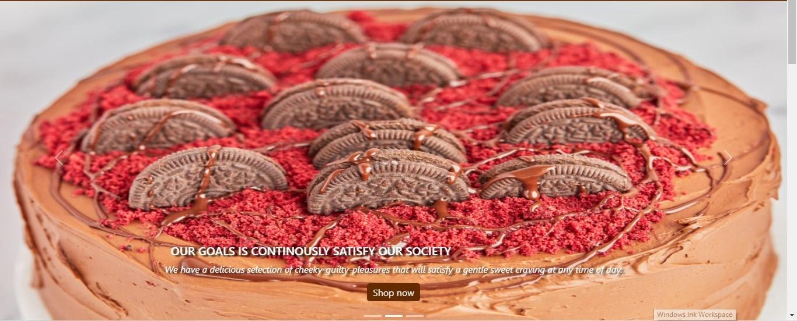



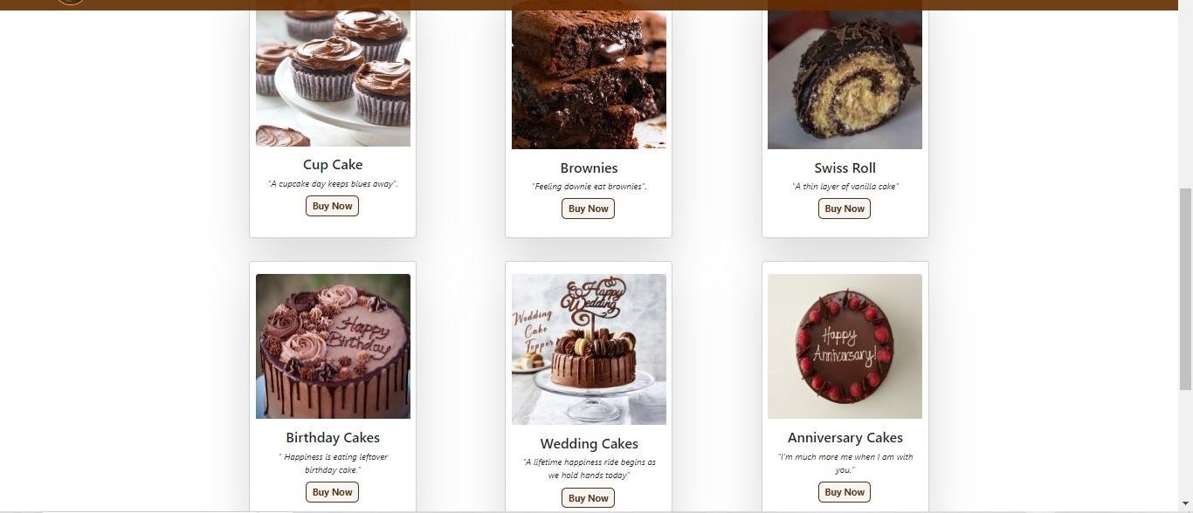



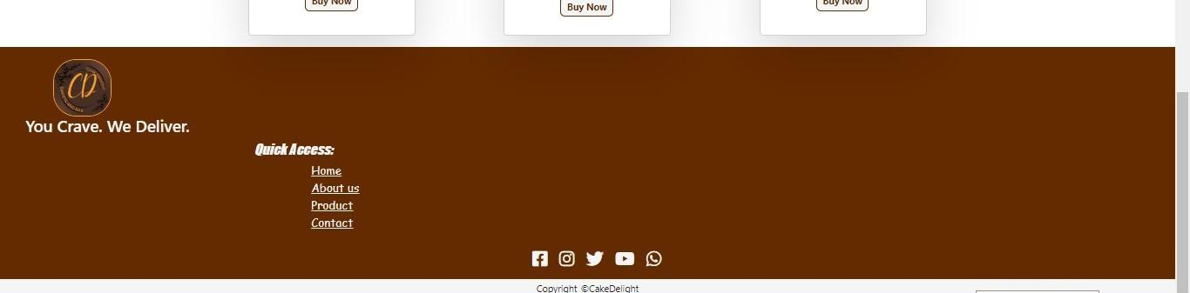



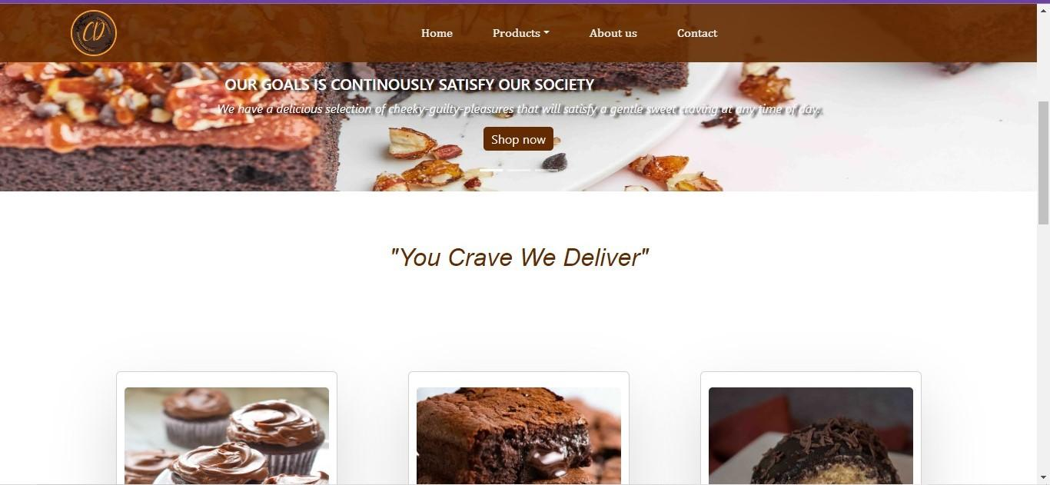



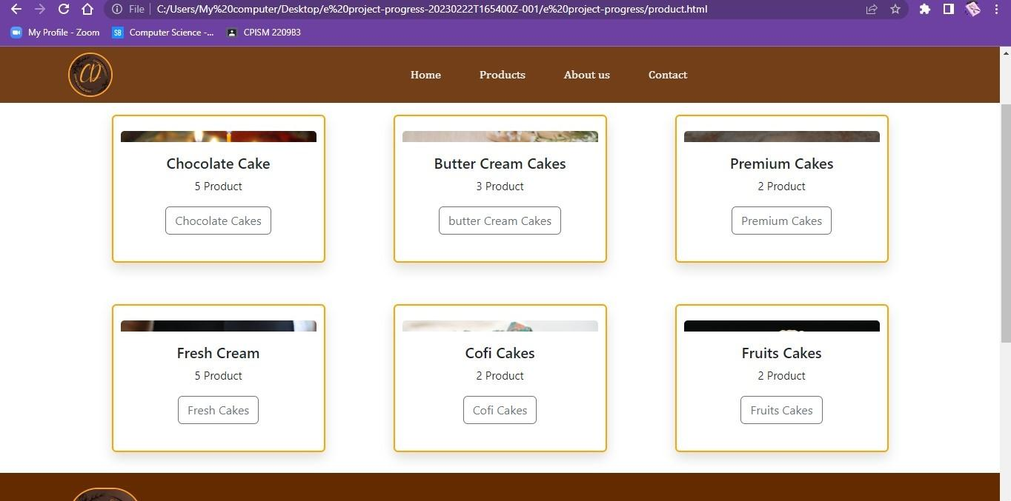



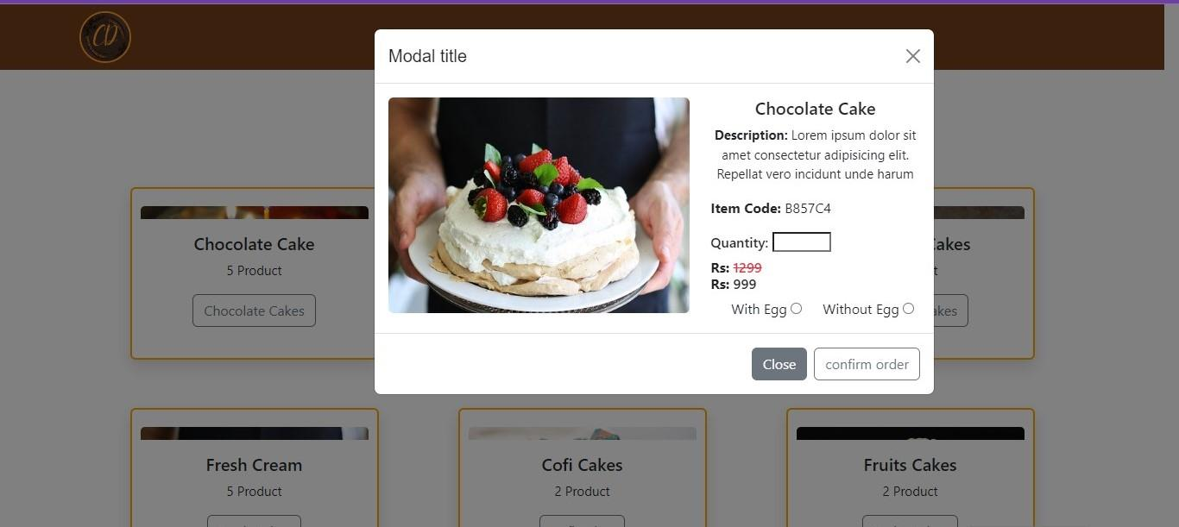

**Checklist of Validations**

|  |  |
| --- | --- |
| Option | Validated |
| Do all text links lead to the appropriate Web pages? | N/A |
| Do all the image links lead to the appropriate Web pages? | N/A |
| Are all the images and links clearly visible on the page? | N/A |
| Is the Web page opening properly in all the tested Web browsers? | N/A |
| Are the animations loading well? | N/A |
| Is the Website responsive? | N/A |
| Is the Website taking too long to load? | N/A |
| Is the Navigation sequence correct through all the Web pages on the site? | N/A |
| Is the JavaScript code working as expected in all click events? | N/A |